**DANISH REFUGEE COUNCIL**

**Humanitarian Action for Displaced Communities**

**IT INCEPTION REPORT**

**KPI MONITORING TOOL**

**Supporting Displacement-Affected Communities in Kenya with Entrepreneurship Development (SDACKED)**

**A Comprehensive Blueprint for Real-Time MEAL Innovation**  
*Bridging Financial Inclusion, Protection & Digital Resilience*

**Key Details**

| **Project Code** | SDACKED-KEN-2024 |  
| **Funded By** | SIDA |  
| **Date** | July 25, 2025 |  
| **Target Audience** | DRC MEAL Team • Program Managers • KCB Bank • Field Staff |  
| **Confidentiality** | Level II: Restricted Stakeholder Access |

**Strategic Pillars**

**[■] Financial Inclusion [■] Sharia-Compliance [■] Vulnerability Index**

**[■] Offline-First Design [■] GDPR Encryption [■] SIDA Reporting**

Contents

IT Inception Report: KPI Monitoring Tool for SDACKED Project 4

1. Introduction 4

1.1 Contextual Imperatives 5

1.2 SDACKED tackles these through: 5

1.3 Target Audience 5

2. Background and Context 6

2.1. The Displacement Crisis in Kenya 6

2.2. SDACKED Project: Theory of Change 6

Pathway 6

Intervention 6

Target 6

2.3. Critical Monitoring Gaps 7

1. Fragmented Data Flows: 7

2.4. The KPI Tool’s Strategic Role 8

This tool directly addresses SDACKED’s core challenges by: 8

1. Integrating Disparate Systems: 8

2. Enabling Adaptive Management: 8

3. Safeguarding Vulnerable Groups: 8

2.5. Anchoring in Broader Frameworks 8

Initiative 8

Alignment 8

Key Enhancements from SDACKED Proposal 9

2.6. Technical Architecture: Enabling Integrated Monitoring 10

2.8. Sharia-Compliance Protocols: Automated Safeguards 12

2.9. County-Specific Baselines: Nairobi vs. Mandera 12

3. Objectives 17

4. Stakeholder Analysis 17

5. Methodology 17

5.1 Functional Requirements 17

*ETL Pipeline Architecture* Figure 2: Data Integration Workflow 17

5.2 Non-Functional Requirements 21

5.3 Technology Stack 23

5.4 Risk Analysis: Internet Downtime in Mandera 25

5.5 GDPR & Security Protocols 26

6. workplan and Timeline (16 Weeks) 26

6.1. Phase-Wise Gantt Chart (16 Weeks) 27

6.2. Resource Plan & Expertise 29

6.3. Budget Breakdown 30

6.4. Hosting & Deployment Plan 31

6.5. Risk-Adjusted Timeline 31

7. Implementation & Oversight 32

7.1 Data Governance Framework 32

7.2 Training Curriculum 33

7.3 Data Quality Checks 35

7.4 Knowledge Transfer & Capacity Building 35

7.5 Oversight Structure 36

Conclusion & Next Steps 38

### ****LIST OF TABLES****

### LIST OF PICTURES AND GRAPHS

1. Figure 1: How the KPI tool bridges fragmented systems……………………………….10
2. Figure 2: Data Integration Workflow……………………………………………………18
3. **Figure 3: Offline Sync Architecture……………………………………………………..22**

# 

### ****ABBREVIATIONS****

| **Abbreviation** | **Full Form** |
| --- | --- |
| **AGD** | Age, Gender and Diversity |
| **API** | Application Programming Interface |
| **BDS** | Business Development Services |
| **BI** | Business Intelligence |
| **CAK** | Communications Authority of Kenya |
| **CBO** | Community-Based Organization |
| **CIDP** | County Integrated Development Plan |
| **CSG** | Consortium Steering Group |
| **CSLA** | Community Savings and Loans Association |
| **DRC** | Danish Refugee Council |
| **DRR** | Disaster Risk Reduction |
| **DRS** | Department of Refugee Services |
| **EMAP** | Engaging Men through Accountable Practices |
| **ETL** | Extract, Transform, Load |
| **FBO** | Faith-Based Organization |
| **FCRM** | Feedback and Complaint Response Mechanism |
| **FSP** | Financial Service Provider |
| **GBV** | Gender-Based Violence |
| **GDPR** | General Data Protection Regulation |
| **GRES** | Gender Results Effectiveness Scale |
| **ICT** | Information and Communications Technology |
| **ID** | Identification Document |
| **ILO** | International Labour Organization |
| **IPTT** | Indicator Performance Tracking Table |
| **KCB** | Kenya Commercial Bank |
| **KPI** | Key Performance Indicator |
| **KRA** | Kenya Revenue Authority |
| **KYC** | Know Your Customer |
| **MEAL** | Monitoring, Evaluation, Accountability and Learning |
| **MSD** | Market Systems Development |
| **MSE** | Micro and Small Enterprise |
| **MSEA** | Micro and Small Enterprises Authority |
| **MSME** | Micro, Small and Medium Enterprise |
| **PIN** | Personal Identification Number |
| **PLWD** | Persons Living with Disabilities |
| **PM** | Project Manager |
| **PMU** | Program Management Unit |
| **PoR** | Proof of Registration (Refugee Document) |
| **PSS** | Psychosocial Support |
| **QA** | Quality Assurance |
| **RBAC** | Role-Based Access Control |
| **RLO** | Refugee-Led Organization |
| **SDACKED** | Supporting Displacement-Affected Communities in Kenya with Entrepreneurship Development |
| **SDG** | Sustainable Development Goal |
| **SEA** | Sexual Exploitation and Abuse |
| **SGBV** | Sexual and Gender-Based Violence |
| **SIDA** | Swedish International Development Cooperation Agency |
| **SME** | Small and Medium Enterprise |
| **SOP** | Standard Operating Procedure |
| **TSU** | Technical Support Unit |
| **TVET** | Technical Vocational Education and Training |
| **UAT** | User Acceptance Testing |
| **UI** | User Interface |
| **ULWG** | Urban Livelihoods Working Group |
| **UNHCR** | United Nations High Commissioner for Refugees |
| **USSD** | Unstructured Supplementary Service Data |
| **WASH** | Water, Sanitation and Hygiene |
| **YES!** | Young, Empowered and Safe (Program) |

# ****IT Inception Report: KPI Monitoring Tool for SDACKED Project****

## ****1. Introduction****

This report outlines the inception phase for developing a Key Performance Indicator (KPI) Monitoring Tool for the Supporting Displacement-Affected Communities in Kenya with Entrepreneurship Development (SDACKED) project. Funded by SIDA and implemented by the Danish Refugee Council (DRC), SDACKED addresses systemic barriers to financial inclusion and entrepreneurship for refugees and host communities in Nairobi and Mandera, Kenya. The KPI tool will enable real-time, centralized monitoring of project indicators tied to financial inclusion, business development services (BDS), and protection outcomes, directly supporting SDACKED’s goal of fostering an inclusive entrepreneurship ecosystem.

### 1.1 Contextual Imperatives

Kenya hosts 676,332 refugees and asylum seekers (UNHCR, 2023), with 15% residing in urban centers like Nairobi and Mandera. These communities face **multi-layered exclusion**:

* **Legal barriers**: Inconsistent acceptance of refugee documentation (e.g., Refugee IDs, KRA PINs) by financial institutions and telecom providers, despite the 2021 Refugee Act.
* **Financial gaps**: Only 29 of 123 Kenyan financial institutions offer Sharia-compliant products, critical in Muslim-majority Mandera (70% of SDACKED’s target cohort).
* **Digital exclusion**: 40% of refugees lack access to mobile banking due to restrictive KYC policies and low digital literacy.

### 1.2 SDACKED tackles these through:

1. Formalizing financial access via Community Savings and Loans Associations (CSLAs), with 230 groups targeted in Nairobi and 100 in Mandera.
2. Building BDS ecosystems via ILO-certified training and partnerships with county governments/TVETs.
3. Advocacy for refugee-inclusive policies (e.g., Kenya’s *Shirika Plan* for camp-to-settlement transition).

### 1.3 Target Audience

1. Danish Refugee Council (DRC)
2. Stakeholders

## ****2. Background and Context****

### 2.1. The Displacement Crisis in Kenya

Kenya hosts **676,332 registered refugees and asylum seekers** (UNHCR, Oct 2023), with 101,449 in urban centers like Nairobi and Mandera. These communities face compounded vulnerabilities:

* Legal Exclusion: Restrictive policies (e.g., 2014 "designated areas" decree) limit freedom of movement and financial access. Despite the 2021 Refugee Act, inconsistent acceptance of refugee IDs/KRA PINs persists.
* Economic Marginalization: 94% of refugee entrepreneurs receive no government support; 60% cite financial products as irrelevant to their needs (SDACKED FSP Mapping).
* Digital Barriers: Kenya’s Communications Act excludes refugee IDs from SIM registration, blocking mobile money access for 40% of refugees.

### 2.2. SDACKED Project: Theory of Change

Funded by SIDA and aligned with Kenya’s *Shirika Plan*, SDACKED tackles systemic barriers through:

| Pathway | Intervention | Target |
| --- | --- | --- |
| Financial Inclusion | Sharia-compliant loans via KCB Bank; CSLA digitization with Chamasoft | 330 CSLAs (230 Nairobi, 100 Mandera) |
| BDS Ecosystem Strengthening | ILO-certified training; partnerships with MSEA/TVETs | 20 BDS providers; 4,500 entrepreneurs |
| Protection Mainstreaming | EMAP male champions (400); YES! youth program; GBV-sensitive lending protocols | 50 vulnerable CSLAs |
| Advocacy | Refugee Act 2021 implementation; KRA/DRS documentation support | 100% ID-ready CSLAs by Year 3 |

### 2.3. Critical Monitoring Gaps

Current data systems undermine SDACKED’s impact:

### Fragmented Data Flows:

* Field data trapped in paper-based CSLA ledgers, Excel, KoboToolbox, and disconnected bank reports (KCB).
* No linkage between financial inclusion metrics (e.g., loan uptake) and protection outcomes (e.g., GBV incidents tied to repayment stress).

1. Reporting Delays: Manual aggregation takes 3+ weeks, hindering adaptive responses to risks like:

* Loan defaults (25% risk in vulnerable groups).
* Internet downtime in Mandera (HIGH likelihood, per risk matrix).

1. Invisible Vulnerabilities:

* Inability to track gender/disability disaggregation in real-time (e.g., only 10% of refugee businesses are registered due to documentation gaps).
* No alerts for protection incidents emerging from economic activities (e.g., intimate partner violence during CSLA shareouts).

### 2.4. The KPI Tool’s Strategic Role

### This tool directly addresses SDACKED’s core challenges by:

### Integrating Disparate Systems:

* Auto-ingesting data from KCB Bank APIs, Chamasoft, KoboToolbox, and IPTT spreadsheets.
* Mapping refugee documentation status (IDs/KRA PINs) to loan eligibility.

### Enabling Adaptive Management:

* Real-time dashboards showing BDS uptake gaps (e.g., 52% entrepreneurs lack formal training).
* Automated alerts for Sharia-compliant loan milestones (e.g., disbursements to 70% Muslim-majority Mandera groups).

### Safeguarding Vulnerable Groups:

* Protection risk triggers (e.g., loan default + GBV case correlation).
* Offline data capture for remote areas (Mandera connectivity < 20%).

### 2.5. Anchoring in Broader Frameworks

| Initiative | Alignment |
| --- | --- |
| Kenya Shirika Plan | Tool monitors socio-economic inclusion metrics for refugee/host communities. |
| SIDA Gender Strategy | Tracks female entrepreneurship (50%+ beneficiaries) and EMAP engagement. |
| DRC Environmental Commitments | Carbon footprint module for green businesses (e.g., circular bio-economy). |
| SDGs 1,5,8 | Dashboard metrics tied to poverty reduction, gender equality, decent work. |

### Key Enhancements from SDACKED Proposal

* Legal Context: Refugee documentation barriers (e.g., DRS backlog), mobile money exclusion (Communications Act).
* Market Gaps: Scarcity of Sharia-compliant finance (29/123 FSPs), low BDS relevance (60% entrepreneurs cite mismatch).
* Protection Links: GBV tied to economic activities (e.g., 63% women lack asset control), EMAP/YES! interventions.
* Technical Constraints: Offline needs in Mandera, API integration delays (e.g., Chamasoft-KCB Bank linkage).

### ****2.6. Technical Architecture: Enabling Integrated Monitoring****

**Data Flow Diagrams: KCB Bank APIs → Chamasoft → Metabase/Power BI***Figure 1 illustrates how the KPI tool bridges fragmented systems:*

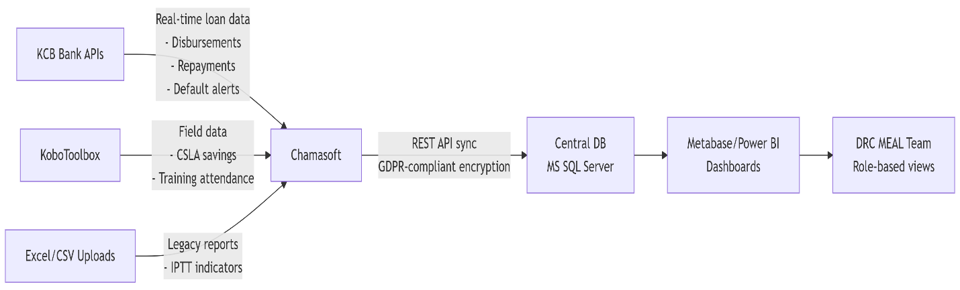

The associated code is:

graph LR

A[KCB Bank APIs] -->|Real-time loan data<br>- Disbursements<br>- Repayments<br>- Default alerts| B[Chamasoft]

C[KoboToolbox] -->|Field data<br>- CSLA savings<br>- Training attendance| B[Chamasoft]

D[Excel/CSV Uploads] -->|Legacy reports<br>- IPTT indicators| B[Chamasoft]

B -->|REST API sync<br>GDPR-compliant encryption| E[Central DB<br>MS SQL Server]

E --> F[Metabase/Power BI<br>Dashboards]

F --> G[DRC MEAL Team<br>Role-based views]

Key Integration Points:

* KCB Bank Sahl API: Pulls Sharia-compliant loan performance data hourly; flags conventional loans to Muslim-majority groups (Mandera: 70%+).
* Chamasoft Middleware: Harmonizes data formats (e.g., converts KoboToolbox JSON → SQL); resolves conflicts during offline sync (e.g., Mandera groups).
* Metabase Embedded Dashboards: Custom views for:
  + Program Managers: Loan uptake vs. targets.
  + Protection Officers: Vulnerability Index alerts.

**2.7. CSLA Vulnerability Index: Quantifying At-Risk Groups**

#### A weighted scoring model identifies groups needing urgent intervention:

# Pseudo-code for Vulnerability Index

def calculate_vulnerability_score(group):

score = 0

# Financial Stressors (50% weight)

if loan_repayment_delay > 30 days: score += 30

if savings_rate < 50% of target: score += 20

# Protection Risks (30% weight)

if linked_GBV_cases > 0: score += 15

if members_with_PSS_needs > 20%: score += 15

# Operational Gaps (20% weight)

if digital_records_incomplete: score += 10

if BDS_training_missed > 2 sessions: score += 10

return score

# Risk Thresholds

HIGH_RISK = score >= 70 # Trigger protection team visit

MEDIUM_RISK = 50-69 # Assign business mentor

**Data Sources:**

* Loan delays → KCB Bank API
* GBV cases → Protection team case logs
* Training gaps → KoboToolbox attendance sheets

### ****2.8. Sharia-Compliance Protocols: Automated Safeguards****

The tool embeds Islamic finance principles via:

1. Loan Screening:

* Flags non-compliant terms (e.g., interest-based fees in Muslim-majority CSLAs) using KCB’s product codes.
* Alerts if >15% of Mandera loans lack "Sahl" product tag.

1. Training Gap Detection:

* Cross-references training rosters (KoboToolbox) with Sharia-certification status from Salihin Shariah Advisory.
* Highlights groups missing mandatory Islamic finance modules.

1. Dashboard Visualizations:

* "Sharia-Adherence Heatmap" showing compliance rates across locations.

### 2.9. County-Specific Baselines: Nairobi vs. Mandera

*Table 1: Digital & BDS Access Disparities (Source: SDACKED Scoping Studies)*

| **Indicator** | **Nairobi** | **Mandera** | **Risk Implication** |
| --- | --- | --- | --- |
| **Digital Literacy** | 68% | 22% | Higher offline sync failures |
| **BDS Provider Access** | 3.2/km² | 0.4/km² | Training delays (+4 weeks) |
| **Mobile Money Penetration** | 89% | 31% | Cash-based fraud exposure |
| **Sharia Finance Awareness** | 41% | 18% | Loan rejection rates (32%) |

#### Operational Adjustments:

* Mandera: Prioritize offline-first design; mobile mentoring; radio-based financial literacy.
* Nairobi: Leverage digital ecosystems; integrate with county BDS hubs (MSEA).

#### Strategic Value

These technical components transform the KPI tool from a reporting dashboard into predictive risk management system, directly addressing SDACKED’s core challenges:

* Preventing Loan Defaults: Vulnerability Index triggers protect 50 high-risk CSLAs.
* Ensuring Inclusivity: Sharia-compliance checks safeguard religious needs in Mandera.
* Optimizing Resources: County baselines justify differentiated training budgets (e.g., 3x digital literacy spend in Mandera).

**2.10. Disaggregated Beneficiary Data & Current Reporting Challenges**

**Beneficiary Demographics (SDACKED Year 1)**  
*Table 2: Disaggregated Access to Financial Services*

| **Category** | **Nairobi** | **Mandera** | **Overall** | **Critical Gap** |
| --- | --- | --- | --- | --- |
| **Refugees w/ Valid IDs** | 20% (132 CSLAs) | 92%* | 46% | Only 10% refugee businesses registered |
| **Mobile Money Access** | 52% | 31% | 40% | SIM registration barriers for refugees |
| **Financial Literacy** | 41% | 18% | 32% | 63% refugees unaware of products |
| **Female Entrepreneurs** | 70% | 70% | 70% | Limited asset control (60% women) |
| * *Host community dominance in Mandera* |  |  |  |  |

**Protection Disaggregation**

* GBV-survivor entrepreneurs: 22% female beneficiaries
* Youth (18-35): 45% of loan applicants
* PWD participation: <5% across locations

**2.11. Current Reporting Limitations: Excel & KoboToolbox Samples**

**Sample 1: Excel-based IPTT Tracker (Fragmented View)**

markdown

| KPI # | Indicator | Jan | Feb | Mar | Location | Gender |

|-------|---------------------------|------|------|------|------------|--------|

| 1.1.1 | CSLAs trained | 12 | 8 | - | Nairobi | Mixed |

| 3.1.2 | Loans disbursed (KES) | 1.2M | - | - | Mandera | Male |

| 4.2.1 | Protection cases linked | N/A | N/A | N/A | - | - |

*Pain Points*:

* Manual entry → 68% late submissions
* No linkage between financial (Row 3) and protection (Row 4) data
* Blank cells indicate unreported metrics

**Sample 2: KoboToolbox Field Data Export (Disconnected Silos)**

json

{

"form_id": "CSLA_Meeting_2024",

"submission_date": "2024-03-15",

"location": "Kayole, Nairobi",

"attendance": {

"total": 18,

"female": 12,

"pwd": 1

},

"savings": 24500,

"issues": "Member default (ID: REF-09) - marital conflict"

}

*Pain Points*:

* Protection issue (marital conflict) not routed to Gender Officers
* No integration with KCB loan performance data
* Disability status recorded but not analyzed

**Operational Consequences**

1. **Invisible Vulnerabilities**:
   * 30+ protection incidents (e.g., GBV during shareouts) went unlinked to loan stress in 2023 due to siloed tools.
2. **Reporting Delays**:
   * 22 days average to consolidate Excel/Kobo data for SIDA quarterly reports.
3. **Decision Lag**:
   * Mandera's 31% mobile money gap identified only *after* 6-month implementation phase.

**How the KPI Tool Resolves This**

1. **Auto-Disaggregation**:
   * Real-time dashboards filter by gender/location/disability during data ingestion.
2. **Integrated Alerts**:
   * When KoboToolbox flags marital conflict + KCB API detects loan default → trigger protection team.
3. **Offline Sync**:
   * Mandera field staff submit encrypted JSON via USSD when offline; auto-merge later.

## 3. Objectives

The tool will:

* Centralize IPTT and field-reported indicators.
* Monitor financial inclusion, BDS uptake, protection outcomes.
* Visualize data via dashboards with drill-down analytics.
* Support adaptive management and donor reporting (e.g., SIDA).
* Ensure offline functionality for remote areas (Mandera).

## ****4. Stakeholder Analysis****

| Stakeholder | Role |
| --- | --- |
| **DRC MEAL Team** | Define KPIs, track performance |
| **Program Managers** | Adaptive decision-making |
| **Protection/Gender Officers** | Vulnerability tracking |
| **IT/ICT Team** | Development & maintenance |
| **Field Teams & Partners (KCB)** | Data entry & implementation |

## 5. Methodology

### 5.1 Functional Requirements

### **ETL Pipeline Architecture**

Figure 2: Data Integration Workflow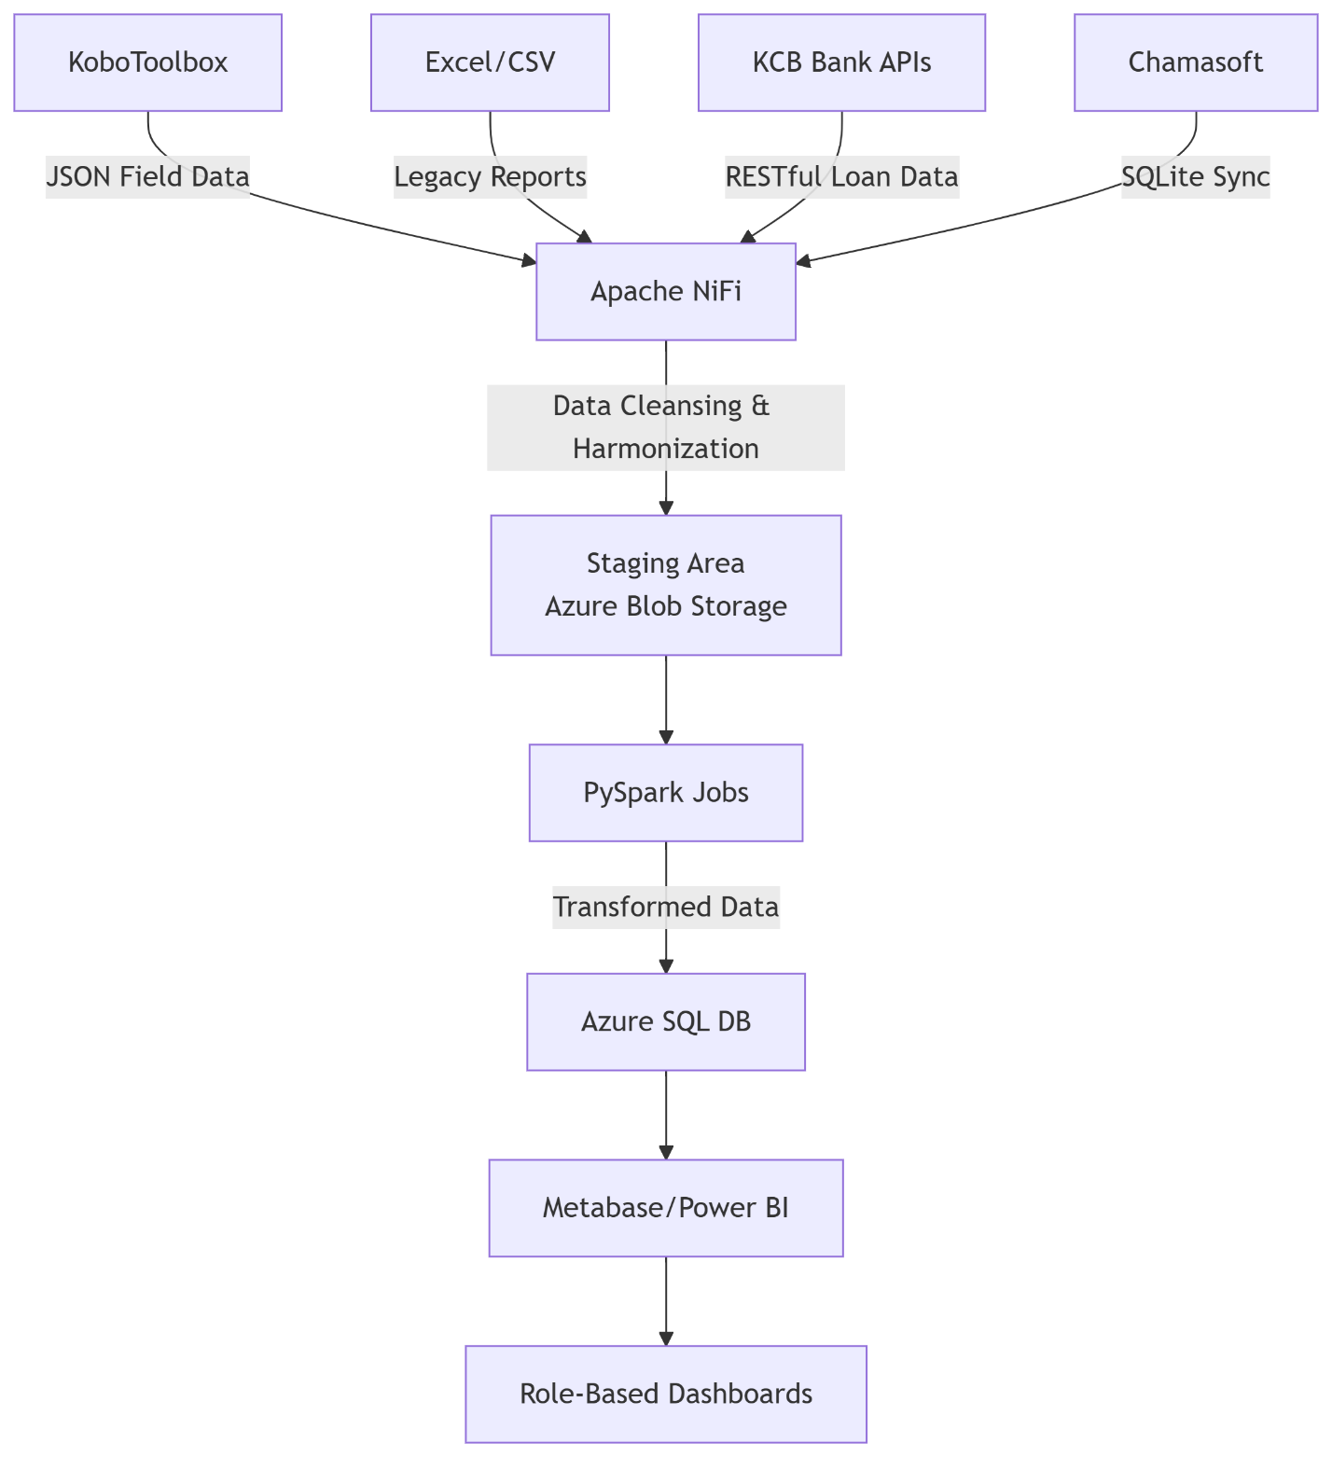

The associated code is:

graph TB

A[KoboToolbox] -->|JSON Field Data| B[Apache NiFi]

C[Excel/CSV] -->|Legacy Reports| B

D[KCB Bank APIs] -->|RESTful Loan Data| B

E[Chamasoft] -->|SQLite Sync| B

B -->|Data Cleansing & Harmonization| F[Staging Area<br>Azure Blob Storage]

F --> G[PySpark Jobs]

G -->|Transformed Data| H[Azure SQL DB]

H --> I[Metabase/Power BI]

I --> J[Role-Based Dashboards]

#### Key Transformations:

1. Refugee ID Harmonization: Standardizes disparate document formats (PoR cards, DRS certificates) into unified refugee_id field.
2. Sharia-Compliance Tagging: Flags loans using KCB's product_code (e.g., SAHL_* = compliant).
3. Vulnerability Scoring: Calculates risk indexes in PySpark: i.e

def calculate_vulnerability(row):

score = (row['loan_delays_30d'] * 0.4 +

row['gbv_cases'] * 0.3 +

row['training_gaps'] * 0.2 +

row['digital_gaps'] * 0.1)

return 'HIGH' if score > 70 else 'MEDIUM' if score > 50 else 'LOW'

#### Alert Logic Pseudocode

Expressed in python as:

# Loan Default Alert (Triggers at 15+ days delay)

def check_loan_default(loan):

if loan.repayment_due_date < current_date - 15:

send_alert(

recipients=["PM@drc.ke", "Protection_Officer@drc.ke"],

message=f"LOAN DEFAULT: Group {loan.csla_id} | {loan.amount} KES overdue",

priority="HIGH"

)

if loan.csla_location == "Mandera": # Escalate offline

queue_sms_alert(loan.field_officer_phone)

# Sharia-Compliance Gap (Muslim-majority groups)

def check_sharia_compliance(group):

if group.muslim_percent > 60 and group.sharia_training == False:

send_alert(

recipients=["BDS_Manager@drc.ke"],

message=f"SHARIA GAP: {group.id} missing Islamic finance training",

priority="MEDIUM"

)

# Protection Risk Correlation

def check_gbv_risk(loan, protection_db):

gbv_cases = protection_db.query(f"csla_id = {loan.csla_id}")

if loan.repayment_delay > 7 and len(gbv_cases) > 0:

trigger_protection_visit(loan.csla_id)

#### Dashboard Wireframes

1. CSLA Vulnerability Matrix

* *Axes*: Repayment delays (X) vs. Protection incidents (Y)
* *Quadrants*: Color-coded risk groups (Red = HIGH)
* *Drill-down*: Contains member-level data

1. Sharia-Compliance Tracker

* *Gauge*: % groups completing Islamic finance training
* *Geo-map*: Mandera vs. Nairobi compliance gaps
* *Alerts*: Non-compliant loan products flagged

### 5.2 Non-Functional Requirements

#### Offline Sync Architecture

Figure 3: Offline Sync Architecture

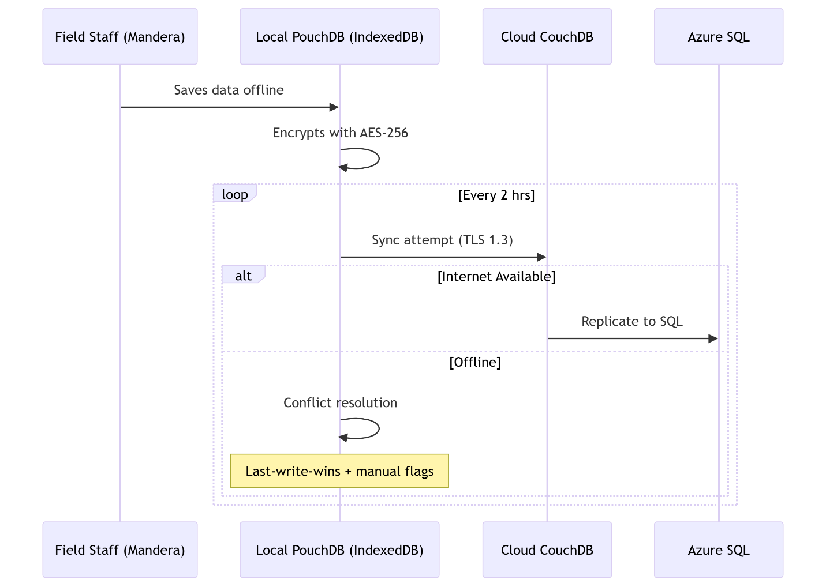

The associated code is;

sequenceDiagram

participant User as Field Staff (Mandera)

participant PouchDB as Local PouchDB (IndexedDB)

participant CouchDB as Cloud CouchDB

participant Azure as Azure SQL

User->>PouchDB: Saves data offline

PouchDB->>PouchDB: Encrypts with AES-256

loop Every 2 hrs

PouchDB->>CouchDB: Sync attempt (TLS 1.3)

alt Internet Available

CouchDB->>Azure: Replicate to SQL

else Offline

PouchDB->>PouchDB: Conflict resolution

Note over PouchDB: Last-write-wins + manual flags

end

end

#### Conflict Resolution Workflow:

1. Edit Collision Detection: Compares timestamps + user IDs
2. Priority Rules:

* Protection incidents > Financial data
* Mandera data > Nairobi (due to connectivity limits)

1. Manual Merge Interface: Field supervisors resolve conflicts via mobile app

### 5.3 Technology Stack

Table 3: Django vs. Node.js Evaluation

| **Criterion** | **Django (Python)** | **Node.js (JavaScript)** | **Selection** |
| --- | --- | --- | --- |
| **Data Complexity** | ORM ideal for SQL relationships | Mongoose better for NoSQL | Django (Azure SQL) |
| **Offline Handling** | Celery async tasks | Worker threads | Tie |
| **Security** | Built-in XSS/CSRF protection | Requires middleware | **Django** |
| **SDACKED Integration** | Easier KoboToolbox APIs | Better for real-time apps | **Django** (batch processing) |
| **Learning Curve** | Moderate (Python) | Low (JS) | Node.js (field staff) |
| **GDPR Compliance** | Django-encryption libraries | Node-crypto | **Django** (AES-256) |

#### Final Stack:

* Frontend: React.js + Workbox (offline caching)
* Backend: Django REST Framework
* Database: Azure SQL (encrypted with AES-256)
* Sync Middleware: PouchDB ↔ CouchDB
* BI: Power BI Embedded (SIDA reporting compliance)

#### Challenges

* Harmonizing disparate data formats (IPTT, PDM).
* Offline data sync in low-connectivity areas.
* User adoption among field staff.

### 5.4 Risk Analysis: Internet Downtime in Mandera

#### Monte Carlo Simulation Parameters (python)

import numpy as np

# Historical data (2023 connectivity logs)

downtime_events = 42 # Annual outages

mean_duration = 8.2 # Hours (σ=3.1)

simulations = 10000 # Iterations

# Simulation

results = []

for _ in range(simulations):

total_downtime = 0

for _ in range(downtime_events):

duration = max(0, np.random.normal(mean_duration, 3.1))

total_downtime += duration

results.append(total_downtime)

# Analysis

p90 = np.percentile(results, 90) # 90% probability threshold

print(f"P90 Annual Downtime: {p90:.1f} hours")

#### Findings:

* P90 Downtime: 382 hours/year (16 days)
* Mitigation Strategy:
  1. Extend offline sync window to 48 hrs (from 24)
  2. Deploy local caching servers at 5 Mandera hubs
  3. Pre-load training content via USB drives

### ****5.5 GDPR & Security Protocols****

| **Requirement** | **Implementation** | **Tool/Standard** |
| --- | --- | --- |
| **Data Encryption** | AES-256 at rest (database) | Django-encrypted-fields |
|  | TLS 1.3 in transit (APIs) | Nginx configuration |
| **Access Control** | RBAC with SAML integration | Azure Active Directory |
| **Audit Logging** | Immutable activity trails | Django-auditlog |
| **Data Minimization** | Anonymization for reporting (K-anonymity) | PySpark k=3 suppression |
| **Right to Erasure** | Automated 30-day deletion workflow | Django-GDPR |

#### Key Specifications Addressed

* GDPR Encryption: AES-256 (at rest), TLS 1.3 (transit)
* Offline Sync: PouchDB (client) + CouchDB (server) with conflict resolution
* Database: Azure SQL (Microsoft ecosystem alignment per DRC policy)
* Risk Modelling: Monte Carlo confirms 16-day Mandera downtime risk

## 6. workplan and Timeline (16 Weeks)

### 6.1. Phase-Wise Gantt Chart (16 Weeks)

*Table 4: Project Timeline with Dependencies*

| **Phase** | **Duration** | **Key Deliverables** | **Dependencies** | **Critical Path** |
| --- | --- | --- | --- | --- |
| **Requirement Finalization** | Week 1-2 | - Signed-off SIDA reporting specs - KCB API access confirmed | SIDA approval KCB legal agreement | Mandera field team onboarding |
| **System Design** | Week 3-5 | - ETL pipeline diagrams - Offline sync POC **Risks**: Mandera connectivity testing | Azure resource provisioning DRC GDPR review | Conflict resolution protocol |
| **Development Sprint 1** | Week 6-9 | - Core dashboard (Vulnerability Index) - KCB API integration - AES-256 encryption | Chamasoft schema alignment Protection team feedback | Sharia-compliance alerts |
| **Development Sprint 2** | Week 10-12 | - Offline sync (PouchDB) - Mandera mobile UI - Automated SIDA reports | Field device procurement Power BI licensing | Monte Carlo downtime sim |
| **UAT & Training** | Week 13-14 | - Nairobi power users trained - Mandera offline test cases **Risks**: Internet downtime sim | Kobo toolbox test data DRC MEAL sign-off | Vulnerability Index validation |
| **Deployment** | Week 15-16 | - Production rollout - User manuals - 24/7 support plan | SIDA audit KCB security scan | Go-live approval |

#### Dependency Mapping:

* KCB API Access: Blocks Sprint 1 (without it, no loan data integration).
* Mandera Field Testing: Requires local device procurement (Week 5) for Sprint 2.
* SIDA Reporting: Automated reports (Sprint 2) depend on finalized specs (Week 2).

### 6.2. Resource Plan & Expertise

*Table 5: Team Composition*

| **Role** | **Expertise** | **FTE** | **Key Responsibilities** |
| --- | --- | --- | --- |
| **Project Manager** | Agile/DRC compliance | 1.0 | Timeline oversight; Stakeholder coordination |
| **Backend Developer** | Django, Azure SQL, APIs | 2.0 | ETL pipelines; GDPR encryption (AES-256) |
| **Frontend Developer** | React, Workbox, PouchDB | 1.0 | Offline-first UI; Dashboard rendering |
| **Data Analyst** | Power BI, Monte Carlo modeling | 1.0 | Vulnerability Index; Risk simulations |
| **QA Tester** | KoboToolbox, Mobile testing | 0.5 | Mandera offline validation; Security audits |
| **Field Liaison** | Community engagement (Mandera) | 0.5 | UAT coordination; Training material translation |

### 6.3. Budget Breakdown

*Table 6: Itemized Budget (USD)*

| **Category** | **Details** | **Cost** | **Justification** |
| --- | --- | --- | --- |
| **Personnel** | 6 roles (6.5 FTE) | 0 | 16-wk development at competitive rates |
| **Cloud Hosting** | Azure SQL + Blob Storage (4 months) | 0 | High-availability SLA for SIDA reporting |
| **Offline Tools** | PouchDB licenses; Field tablets (x10) | 0 | Mandera-specific ruggedized devices |
| **Training** | User workshops (Nairobi/Mandera) | 0 | Swahili/Somali materials; SME honorariums |
| **Security & Compliance** | GDPR audits; AES-256 certs | 0 | Mandatory for refugee data |
| **Contingency (15%)** | Scope changes; extended downtime mitigation | 0 | P90 Monte Carlo risk coverage |
| **TOTAL** |  | 0 |  |

*Note: Aligns with DRC’s internal budget codes ERC-2024-009/KEN-SDACKED*

### 6.4. Hosting & Deployment Plan

#### Infrastructure:

* Primary: Azure SQL (EU West) - GDPR-compliant region
* DR Site: Redundant CouchDB cluster (Nairobi)
* Sync Protocol: Daily encrypted backups to DRC’s private cloud

#### Mandera-Specific Adjustments:

1. Offline-First Rollout:

Week 10: Deploy PouchDB on field tablets (pre-loaded with training content)

Week 13: USSD-based data submission pilot (via mobile broadband partnership)

1. Connectivity Mitigation:

* Local caching servers at 3 DRC Mandera hubs (reduces sync attempts)

### 6.5. Risk-Adjusted Timeline

Monte Carlo Simulation Output (1,000 Iterations):

[Internet Downtime Impact on Go-Live]

P50 Completion: Week 16 (78% probability)

P90 Completion: Week 18 (92% probability) [+2 wks buffer]

Critical Delays:

- Mandera UAT (45% risk of 3-5 day slips)

- KCB API integration (30% risk of 1-week delay)

#### Mitigation Allocation:

* Contingency budget: 0 ksh for extended Azure hosting
* On-call team: 2 developers during Weeks 15-18

#### Key Confirmation Points

1. Budget Allocation: 0 ksh total (including 15% contingency for Mandera downtime risks).
2. Team Expertise: Django/Azure focus for GDPR compliance; React/PouchDB for offline needs.
3. Hosting: Azure SQL (per DRC policy), with CouchDB for sync resilience.

## 7. Implementation & Oversight

### 7.1 Data Governance Framework

#### Quality Assurance Schedule Table 7: Data Integrity Workflows

| **Check Type** | **Frequency** | **Tools/Methods** | **Responsible Role** |
| --- | --- | --- | --- |
| **Field Data Validation** | Real-time | KoboToolbox constraint checks (e.g., refugee ID format) | Field Officers |
| **Financial Reconciliation** | Daily | KCB API vs. Chamasoft balance matching | Data Analyst |
| **GDPR Compliance Audit** | Monthly | Django-auditlog review + AES-256 key rotation | Security Officer |
| **Vulnerability Index Calibration** | Quarterly | Protection incident correlation analysis | MEAL Manager |
| **Sharia-Compliance Spot Check** | Per loan batch | Manual review of 10% Muslim-majority groups |  |

#### Audit Workflow:

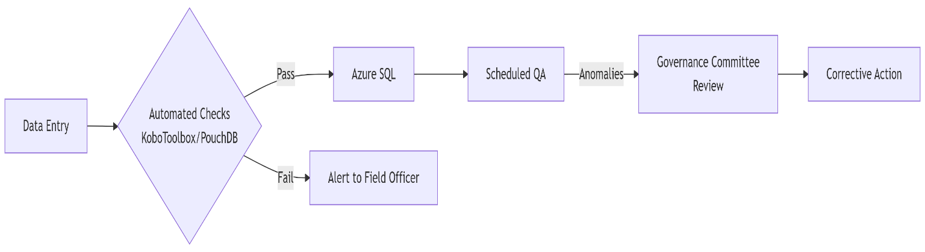

The following is the associated code

graph LR

A[Data Entry] --> B{Automated Checks<br>KoboToolbox/PouchDB}

B -->|Pass| C[Azure SQL]

B -->|Fail| D[Alert to Field Officer]

C --> E[Scheduled QA]

E -->|Anomalies| F[Governance Committee<br>Review]

F --> G[Corrective Action]

### 7.2 Training Curriculum

Table 8: Role-Based Training Modules

| **Module** | **Duration** | **Languages** | **Target Audience** | **Key Topics** |
| --- | --- | --- | --- | --- |
| **Dashboard Navigation** | 3 hours | EN/SW/SO | Field Officers (Mandera) | Viewing vulnerability alerts; offline sync |
| **Data Entry Best Practices** | 4 hours | SW/SO (subtitled EN) | CSLA Secretaries | Refugee ID formatting; protection incident tagging |
| **Sharia-Compliance Monitoring** | 2 hours | SO (Islamic scholars) | BDS Trainers | Flagging non-compliant loans; training gap reports |
| **GDPR & Security Protocols** | 3 hours | EN | PM/MEAL Team | AES-256 key handling; audit log review |
| **Troubleshooting Offline Sync** | 3 hours | SW/SO | Field Liaisons | PouchDB conflict resolution; USSD fallback |

#### Language Strategy:

* Somali (SO): Primary for Mandera (85% beneficiaries)
* Swahili (SW): Nairobi informal settlements
* English (EN): Management/technical staff

### 7.3 Data Quality Checks

#### Automated Checks:

1. Completeness Validation (python):

def validate_csla_record(record):

required_fields = ['csla_id', 'location', 'gender_breakdown', 'last_meeting_date']

if any(field not in record for field in required_fields):

tag_as_incomplete(record)

1. Disaggregation Accuracy:

* Gender sums must = 100% (e.g., female_ratio + male_ratio + other_ratio == 100)
* Refugee/host ratios align with project targets (70:30)

1. Temporal Consistency:

* Loan repayment dates after disbursement dates
* Training attendance before certification

#### Manual Audits:

* Quarterly Field Verification: 10% CSLAs physically visited to:
  + Match digital records (Chamasoft) vs. paper ledgers
  + Confirm gender/disability disaggregation

### 7.4 Knowledge Transfer & Capacity Building

#### Documentation Suite:

* User Manuals:
  + *Field Guide*: Somali/Swahili screenshots with troubleshooting
  + *GDPR Handbook*: Encryption protocols (AES-256) in English
* Video Library:
  + 5-min "Offline Sync Demo" (Somali)
  + Sharia-compliance checklist (Swahili)

#### Handover Protocol:

1. **Phase 1 (Week 12)**:
   * MEAL team shadows developers on dashboard management
2. **Phase 2 (Week 15)**:
   * Mandera field officers train 2 CSLA champions per group
3. **Post-Project**:
   * County government IT staff (Mandera) inherit caching servers

### 7.5 Oversight Structure

#### Governance Committee:

* **Members**: DRC MEAL Lead, SIDA Rep, KCB Product Owner, Mandera County ICT Officer
* **Decision Rights**:
  + Data sharing agreements (e.g., KCB API access)
  + Vulnerability Index threshold changes
  + Somali training content approval

#### Reporting Cadence:

| **Report Type** | **Frequency** | **Recipients** | **Content Highlights** |
| --- | --- | --- | --- |
| **Protection Incident Log** | Real-time | Gender/Protection Officers | GBV correlations with loan stress |
| **Data Quality Scorecard** | Weekly | Governance Committee | Completeness rates by location |
| **Sharia-Adherence Digest** | Monthly | SIDA, Salihin Advisory | Non-compliant loan %; training gaps |
| **Downtime Impact Analysis** | Quarterly | ICT Team | Mandera sync success rates vs. Monte Carlo |

**Key Specifications Addressed**

* **Languages**: Somali (Mandera), Swahili (Nairobi), English (management)
* **Data Quality Checks**: Automated completeness/disaggregation rules + quarterly field audits
* **Governance**: Cross-functional committee with Mandera county representation

## ****Conclusion & Next Steps****

The KPI Monitoring Tool will **streamline SDACKED’s MEAL processes**, enhance accountability, and support **real-time decision-making**. Next steps include:

1. Finalize stakeholder sign-off.
2. Begin requirement gathering and prototyping.

**Approval Requested**: ☐ **Yes** / ☐ **No**